SUMMER BRIDGING WORK 2023

Summer Bridging Work is an important part of your transition to Wilberforce Sixth Form College. This piece of work will count towards your effort grade. Please complete your summer bridging work in time for the start of term.

You are required to bring evidence in paper format and hand this into your subject teacher during your first lesson.

Applied Science & Forensic Investigation

OVERVIEW OF SUBJECT
Scientific and Forensic Investigation has become incredibly important in tackling crime and technology has made massive steps forward in its development allowing more crimes to be solved. It can help to solve all sorts of crimes, typically murders and rape cases but is also used in tackling art fraud, protecting species of animals and plants that are endangered and at threat of extinction and in genealogy. Your studies in Applied Science and Forensic Investigation will enable you to develop your knowledge of science and then apply it to Forensic Investigations. You will take part in crime scene investigations, develop your key scientific practical skills and learn principles of Biology, Chemistry and Physics.

ENTRY CRITERIA
A minimum GCSE average of 5.0 and grade 3 in GCSE English Language and Maths. A minimum of a grade 4 in GCSE Science or equivalent. You can use Level 2 Applied at Pass with 2 merit units to progress with GCSE resits in Maths and English at grade 4.

LITERACY TASK
Write a report outlining the skills that you think are necessary for this course. You should explain why the skill is important and how you would hope to develop your own skills on the Forensics course. You should consider practical scientific skills as well as investigative skills and interpersonal skills such as communication, working in a team, being self-motivated and working safely and carefully. Your report should be around 500 words long.

NUMERACY TASK
Hair - is it animal or human? Calculate the ratio of the diameter of the medulla (middle, pigmented section of the hair) to the diameter of the entire hair. Animal hair exhibits a ratio of .5 or higher. A ratio less than .5 would be considered to be a human hair.
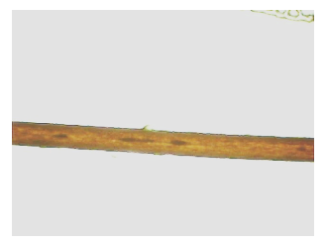
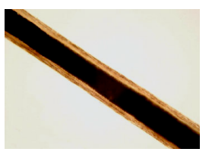

Medulla

Which of the above hairs is likely to be human? Please set out your working out clearly and logically.

PROGRESSION OPPORTUNITIES

Below we have listed four careers linked to Forensic and Criminal Investigation. You are tasked to research the four careers, choose one that most appeals to you and write a 200-word essay as to why you feel this career would be most suited to you.

Forensic Scientist
Forensic Anthropologist
Scene of Crime Officer
Forensic Geneticist

Kind regards

Lois Thorley
Faculty Head for Science and Health

If you have any queries regarding your Summer Bridging Work, please contact me via email ljt@wilberforce.ac.uk
I will aim to respond before your enrolment appointment.

